**Storyboarding**

**Ident Storyboard**

**Trailer Storyboard**

Clip 1:

5 secs?

Fade in from black to one of the flyover shots

Audio background music starts

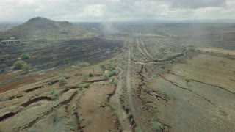

Clip 2:

5 secs

Fade out and in to the control room scene, video overlay to state a name and title of the voiceover.

Voiceover: “We are (company name) and welcome to just one of the worlds…”

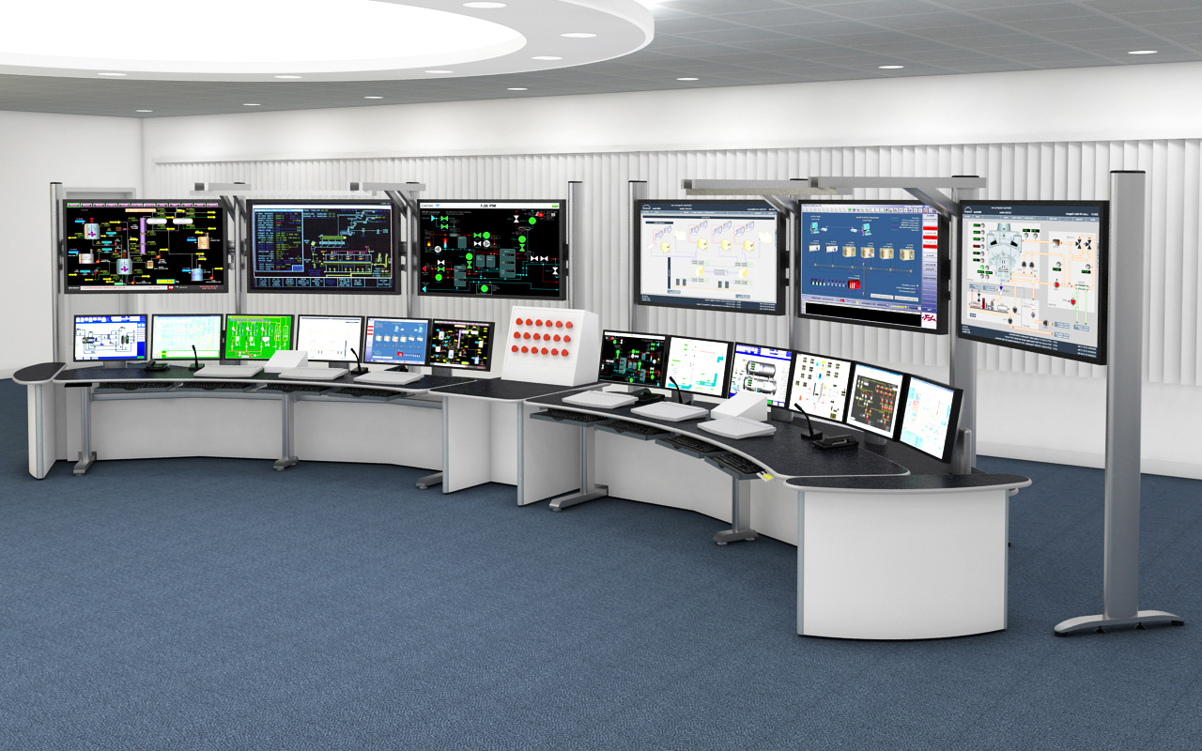

Clip 3:

10 secs

Voiceover: “…we have created, exclusively for our customers. We here at (company name) are the forerunner in world creation technology. Here at (company name) we build worlds.

Switch to several different shots of one of the running tracks we have yet to build to showcase the ‘world’.

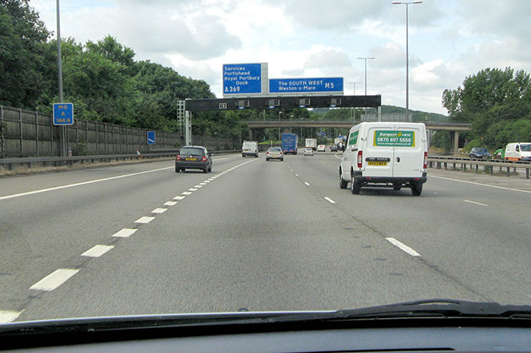

Clip 4:

10 secs

Over the shoulder shots of people coding or working.

Voiceover: “Using the latest in innovative design and advanced software, our brilliant and hardworking designers work tirelessly to create the best virtual world for your needs.”

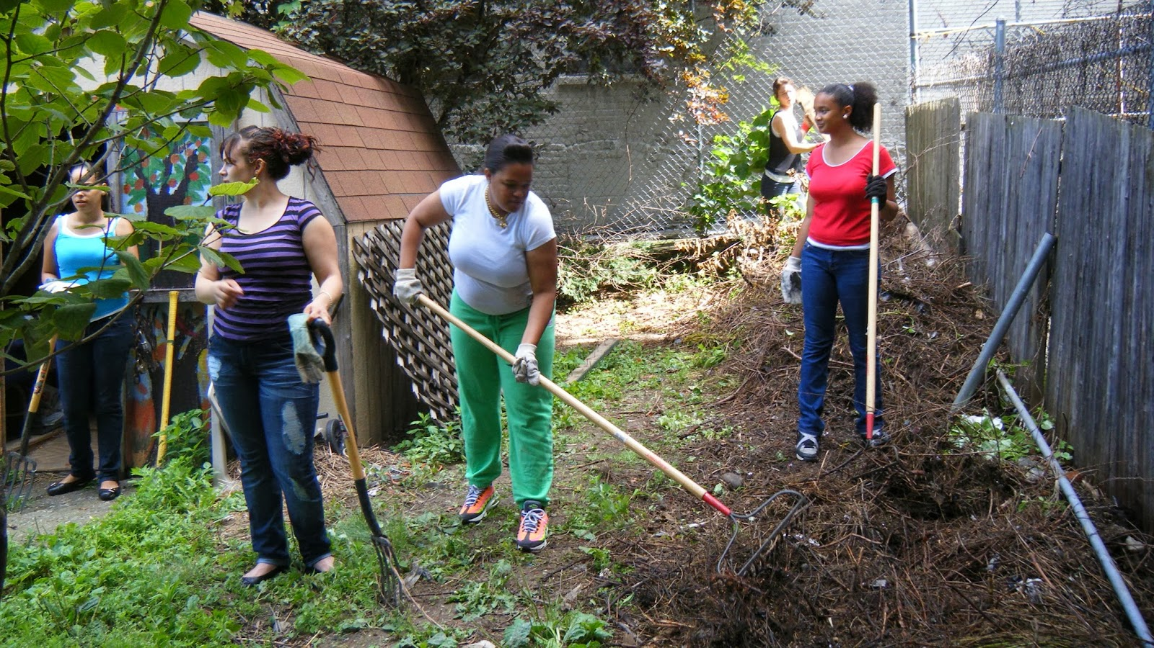

Clip 5:

10 secs

Video overlay: Pop up explaining name and person’s title

Interviewee: “Blah blah blah, I love my job and we’re so great, blah blah blah.”



Clip 6:

20 secs

Voiceover: “Delve into the countless worlds of our creation and escape the mundane and boring grind of everyday, and experience something more. Much more than you will ever experience in your real life. With our tailor made worlds for you to inhabit, you can experience life the way you want to wearing your virtual reality headset of choice and escape your crushing reality.”

Shots of people wearing VR gear with a second screen showing what they are seeing.

On screen text to tell people that we don’t actually make the VR gear.



Clip 7:

10 secs

Shots of the control panel changing the world around them

Voiceover: “With our latest technology, you are in charge with our latest high tech world processing and control technology. Choose the world that is right for you. (company name)”

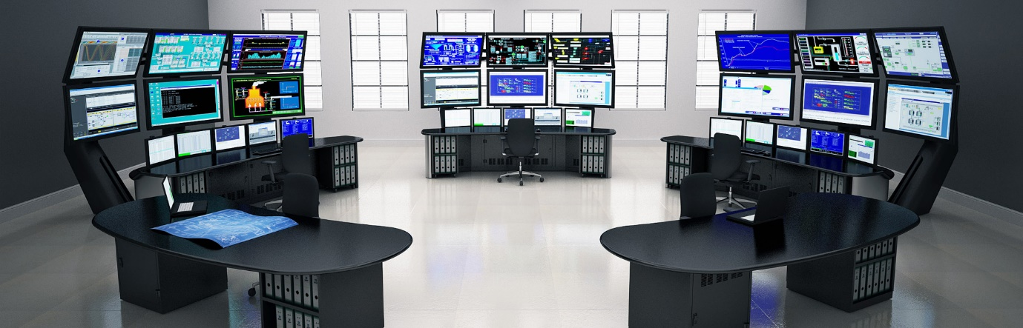

Clips 8:

12 seconds

Ident plays

Fade out music